Call for Exhibitors
CIVITAS Forum Conference

October 20-21, 2021
Aachen, Germany (and online)

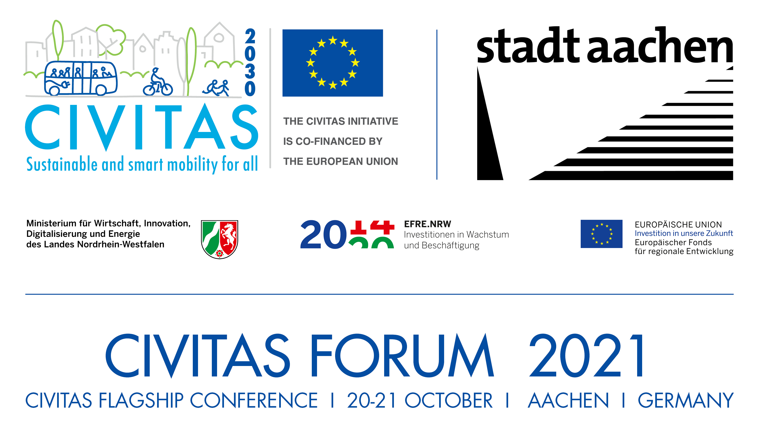

About the CIVITAS Forum Conference
The CIVITAS Initiative, established in 2002 by the European Commission, supports cities with the development and implementation of sustainable urban mobility measures.
The 18th edition of the CIVITAS Initiative's flagship event will gather the keenest mobility minds from across Europe and beyond to discuss the most pressing topics in the field. The conference will take place on October 20-21, 2021 in Aachen (Germany), in a hybrid format.
The conference is a great opportunity to share experiences and know-how with mobility experts, European politicians and the CIVITAS Forum Network – consisting of more than 340 cities from 42 countries that are formally committed to sustainable urban mobility.
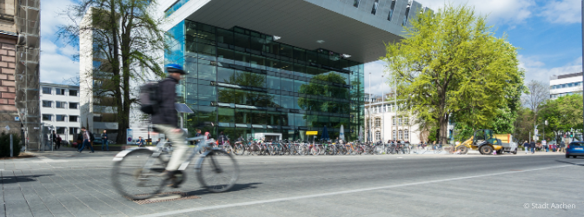

Why the Forum?
The Forum presents an ideal opportunity for projects, organisations, and businesses of all sizes to interact with local, regional, and national government representatives, as well as delegates from European and international institutions.
Being a Forum exhibitor enables you to showcase your company, organisation, products, and solutions to prominent actors in Europe's sustainable urban mobility community.
This year, the Forum Conference is expected to gather 1000 participants online and 250 onsite. This is a realistic estimation, given that the previous two events promoted by the CIVITAS Initiative attracted even more participants (1393 participants during the fully digital ‘Urban Mobility Days 2020’ and 650 participants on-site at the CIVITAS Forum Conference 2019 in Graz).
Having an exhibition stand at the CIVITAS Forum Conference 2021 is, therefore, an excellent opportunity for stakeholders to promote themselves to a broad audience both on-site and online (through the event website and streaming platform).

The details
Since the CIVITAS Forum Conference 2021 will be hosted as a hybrid event, exhibitors can apply to have their stand onsite, in Aachen; online, in a digital ‘booth’, through the streaming platform; or both on-site and online.
For the online stand, exhibitors will have a dedicated page with branded banners and links to content or representatives of your exhibition. Attendees will be able to book meetings with you before, during and after the main conference days.
For the on-site stand, there will be a main exhibition area where 2x2 meter stands will be assembled. Each of them will be furnished with 1 bar table with cover and 2 high chairs, similar to what is presented in the image below:
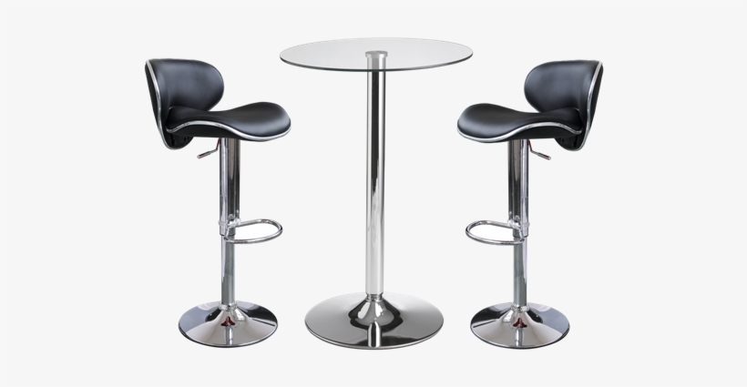
For on-site exhibitors, the CIVITAS Forum Conference 2021 organising team kindly asks you to try to reduce the number of printing materials in your exhibition space. Let’s try to make an event with as little waste as possible!

The prices
On-site Stands
The prices for exhibitor spaces are divided into the three categories listed below:
For CIVITAS projects: | For EU projects & NGOs/ NPOs: | For commercial exhibitors:
Exhibition space: 2x2 m  Fee: 0.- Euro | Exhibition space: 2x2 m  Fee: 150.- Euro excl. taxes | Exhibition space: 2x2 m  Fee: 400.- Euro excl. taxes

Prices include:
- Power supply: 1 power plug 230 V;
- Furnishing: 2 high chairs and 1 bar table with cover.

Note:
For on-site exhibitors it is possible to arrange the shipment of materials directly to the venue. Exhibitors are fully responsible for the timely delivery of their packages. Equipment and packages must not be delivered before October 18, 2021. Further information on shipment will be provided after registration confirmation.

Online Stands
For exhibitors who will have a stand on-site in Aachen at the CIVITAS Forum Conference, they are also entitled to have an online stand on the online platform, free of charge.
If exhibitors only want to be present online, the prices for them are listed in the two categories below:

For CIVITAS projects, EU projects & NGOs/ NPOs: | For commercial exhibitors:
Exhibition space  Fee: 0.- Euro | Exhibition space  Fee: 150.- Euro excl. taxes

Booking your exhibition spot
To guarantee your exhibition space (either on-site, online, or both), please fill in the form available below and send it via email to forum@civitas.eu

Form (mandatory questions are marked with *)

Form
Organisation *
Content *
Please briefly describe what will be promoted at your stand (Max. 200 words)
Address *
Person of Contact *
Email *
Telephone *
Type of Exhibitor * | CIVITAS Project EU Project or NGOs/ NPOs Commercial
Exhibitor Space * | Onsite Online Online & Onsite

If you have chosen to have an exhibition stand on-site, please indicate if you intend to participate in the Forum Conference on-site:

Onsite Stands
Participation in the CF2021 (on-site) * | Yes No
*Please, take into consideration that your answer to this question does not replace the CIVITAS Forum Conference registration process. In this sense, if you wish to participate in the conference, please register at the following link. If you do not wish to attend the conference, on the day of the Forum you will be given a badge with access to the exhibition area only.

If you have any special requests that you would like to see addressed, please indicate them in the box below. Please note that, although we will try to accommodate these requests, they still pend approval and confirmation by the CIVITAS Forum Conference organising team.

Special Request(s)

Disclaimer: Exhibition spaces for will be offered on a first-come, first-served basis to CIVITAS projects. Exhibitors representing non-CIVITAS projects, NGOs, NPOs and commercial entities will be subject to internal approval, in which their relevancy to the Forum theme will be evaluated.

The deadline for applications is September 8, 2021!

If you have any questions, please contact the CIVITAS Forum organising team at the following address: forum@civitas.eu

We look forward to seeing you in Aachen (or online) in October!

