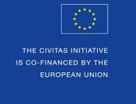

CIVITAS Forum
Annual Conference

Brest, France
30th September - 2nd October 2013

Speaker Contributions to the CIVITAS Forum Conference
Guidelines and Proposal Form

The CIVITAS Forum Conference – Great Chance for Marketing!

The CIVITAS Forum Conference is the annual flagship event of the CIVITAS Forum Network of cities. The 2013 Annual CIVITAS Forum Conference will be hosted by ‘Brest metropole oceane’ (France), between 30th September and 2nd October 2013, and expect around 400 participants.

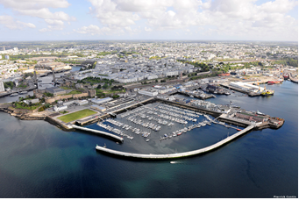The Conference is an opportunity for the exchange of dialogue and views between cities and European politicians on the one hand, and experts in the field of urban mobility on the other. The 2013 conference will be the 11th such annual event, following for a previously hosted in Victoria-Gasteiz, Funchal, Malmö, Krakow, Bologna, Kaunas, Burgos, Nantes, Rotterdam and Graz where the series started in 2003. The CIVITAS Forum Network currently includes 216 cities from 31 European countries, that have formally committed to clean and sustainable urban transport.

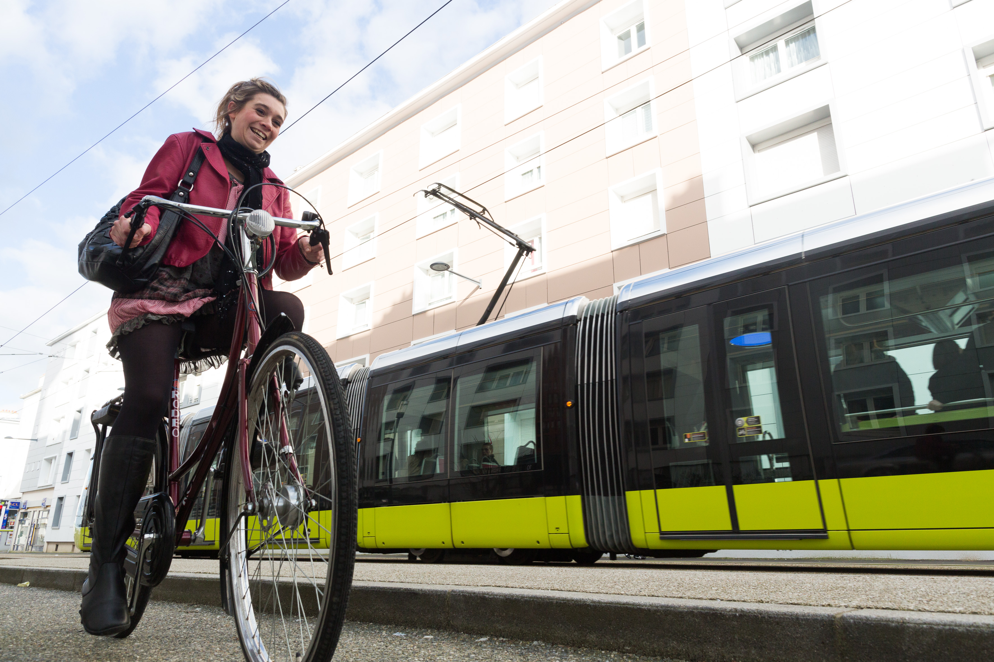
As always, the Forum Conference will be a significant occasion for high level representatives of the European Commission to share news and information on its policy and programme initiatives, and to hear the views of local politicians, mobility practitioners, academics, and non-governmental organizations.

There will be plenty opportunities for the exchange of experience and know-how among urban mobility practitioners from Europe and beyond, via Technical Sessions and round table discussions.

The CIVITAS Forum Conference – Great Chance for sharing ideas!

GUIDELINES

This document serves as the proposal form for speakers interested in contributing to one of the technical sessions, round table sessions and Pecha Kucha sessions of the CIVITAS Forum Conference 2013.

Submission and evaluation procedure

Please carefully read these guidelines, complete the form available below (page 5) and send it via email by 31st May, 2013 to:

civitas.forum@inovamais.pt

The CIVITAS Programme Committee (which consists of the leading organisers together with the EC) will evaluate all proposal submissions. Selected speakers will be contacted by mid-June, when they will be invited to confirm their participation. The calendar is therefore as follows:

Deadline - call for contributions | 31st May
Announcement - selected speakers | 17th June
Deadline - speakers to confirm | 28th June

Tips for a successful technical session/round table proposal

- Be clear and concise about your contribution, stick to the word limitation where appropriate;
- Be ready to present results, and the reasons for a measure’s success;
- Highlight the added-value of CIVITAS and its potential for transferability
- If you feel you can make a valid contribution to more than one technical session, please feel free to duplicate Part II below as many times as necessary. In this case, please indicate your preferences, if you have strong interest in one particular session over another.

Tips for a successful Pecha Kucha proposal

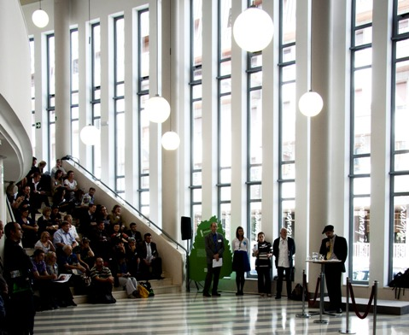Pecha Kucha, devised in Tokyo in 2003 and drawing its name from the Japanese term for the sound of "chit chat", it rests on a presentation format that is based on a simple idea: 20 images, each in 20 seconds. It's a format that makes presentations concise, and keeps things moving at a rapid pace.

As urban mobility faces toward new approaches and new ways of thinking, Pecha Kucha, as format of dissemination, is more and more popular among stakeholders of urban mobility and recently it has become an usual element of the CIVITAS annual conferences agenda.
Therefore CIVITAS Forum Conference 2013 also issues a call for Pecha Kucha presentations. We would like to have a happy bunch of colourful ideas from very different spheres. As introducing presentations from very different areas of urban mobility, we would like to suggest how complex our common thinking can be.
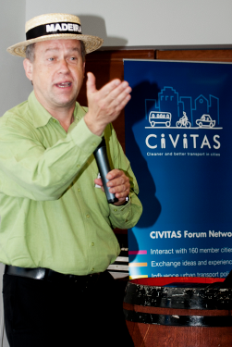
With support of exactly 20 PowerPoint slides the speakers are expected to give their presentation of 6 minutes and 40 seconds, with short breaks between presentations, allowing some Q&A.
Your talk cannot be commercial. Nor can it be a “reduced” version of the talk or workshop you are giving at the conference anyway.

The presentation slides can only contain images, no words, graphs but NO animation, video or music. Make your picture slides simple, straightforward and self-explanatory (and 1 title page to start with). You are requested to send a copy of the presentation beforehand.

Some recommendations – what to use in your Pecha Kucha presentation:
- Funny pictures, jokes, humour
- Metaphor
- Good quality pictures, possibly one big one per slide
- Avoid all text. This is for emotions, not for logic.

PROPOSAL FORM

PART I. Your Contact Details
Name:
Job title:
Organisation:
Address:
Email:
Telephone:
Fax:
CIVITAS project
(if appropriate):

CIVITAS Status: | CIVITAS Plus II CIVITAS Plus CIVITAS II CIVITAS I  CIVITAS Forum Member Non-CIVITAS personality

PART II. Your Contribution
Technical session Round table Pecha Kucha
Presentation title:
Abstract:
Innovative approach:
Broader context of your city’s mobility strategy:
As per the integrated approach of CIVITAS, please describe the “winning combination” of mobility measures and how they reinforced one another:
4-6 Keywords
CIVITAS thematic category addressed (only one) | Clean fuels and vehicles  Collective passenger transport  Demand management strategies  Mobility management  Car-independent lifestyles  Safety and security  Urban freight logistics  Transport telematics

Should you have any question, please contact Chiara Frencia at civitas.forum@inovamais.pt

