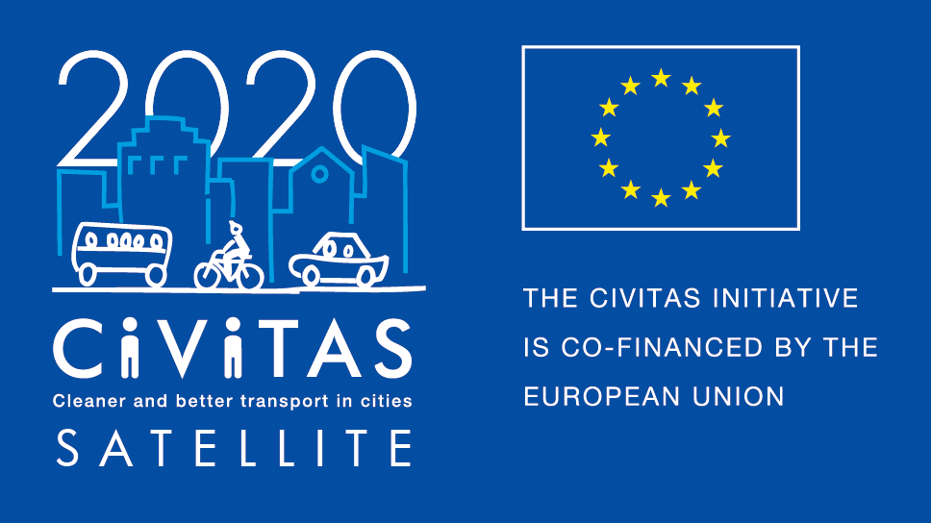
w
CIVITAS peer-exchange
programme
2018 Call for host cities
Application form for host cities
Project Acronym: | CIVITAS SATELLITE
Full Title: Support Action Towards Evaluation, Learning, Local Innovation, Transfer and Excellence
Grant Agreement No.: | 713813
Deadline for applications: 31 October 2018
Contact person: Peter Staelens, Eurocities
peter.staelens@eurocities.eu

CIVITAS SATELLITE peer-to-peer activities in a nutshell

CIVITAS SATELLITE is an initiative designed to support cities in gaining better access to innovative solutions and to address transport challenges by applying exchange mechanisms for transfer and take-up.

Between 2017 and 2020, SATELLITE will organise at least 20 visits in the form of work placements and study visit, for city representatives willing to learn from and exchange extensively with each other.

Participants for these peer-to-peer visits will be selected each year through calls for expressions of interest.

This call is for cities willing to host a SATELLITE work placement or a study visit in 2019.

What is a work placement?
CIVITAS SATELLITE work placements offer transport professionals hands-on learning experience in another European city that leads in a specific area of sustainable urban mobility. These three-day placements will focus on a concrete topic and respond to a local challenge faced by the applicant/visiting city. The main objective is to transfer practical knowledge and expertise from the host city to help achieve a specific objective. Financial support is available to cover travel and accommodation costs.

What is a study visit?
CIVITAS SATELLITE study visits offer the opportunity for up to 10 city representatives to travel to another European city facing similar challenges in sustainable urban mobility to learn about possible solutions and best practices. Typically lasting two to three days, these study visits will be tailored to the needs of the participating cities and take an interactive approach to facilitate in-depth exchange and strengthen cooperation. City representatives will benefit from financial support covering travel and accommodation costs.

Why join CIVITAS SATELLITE peer-to-peer programme?
If you are a host city, you will…
- Have the chance to showcase your city’s achievements in the field of sustainable urban mobility;
- Have the opportunity to exchange on a one-to-one basis with peers;
- Be featured on the CIVITAS website and European-wide media outlets through a dedicated article/interview;
- Be offered speaker slots at high-level European events.

What will CIVITAS SATELLITE provide in terms of funding and support?
If you are a host city, you will..
- Receive support in the organisation of the visit (facilitating contacts with visiting cities, elaborating the agenda of the visit).
- Financial support of up to €500 per work placement and €1000 per study visit.

What will be the tasks of cities involved?
If you are a host city, you will
- Liaise with the CIVITAS SATELLITE team to agree on the objectives of the visit.
- Develop a work placement / study visit programme, with the support of CIVITAS SATELLITE, tailored towards the challenges identified by the visiting city’s representative.
- Provide documentation outlining the key points of practices implemented locally.
- Ensure in liaison with CIVITAS SATELLITE team that all logistical arrangements are put into place.

Apply!
Do you want to host one of the CIVITAS SATELLITE peer exchanges in 2019? Please fill in the questionnaire below by 31 October 2018 and send it back to peter.staelens@eurocities.eu.
Please note that the call for visiting cities will follow and you can apply both as host and as visitor!

Contact person:
If you have any questions, please contact Peter Staelens at EUROCITIES:
Email: peter.staelens@eurocities.eu
Telephone: +32 2 552 0886

CIVITAS SATELLITE Call for host cities
- Fundamental information
Name of the city & Country
Structure & size | ☐ City  ☐ Metropolitan area  Population:
What kind of visit do you want to host? | ☐ Work placement  ☐ Study visit
Are you member of the CIVITAS Community? | ☐ CIVITAS demonstration city  ☐ CIVITAS Forum network city  ☐ CIVINET member city  ☐ IA or RIA project partner city  ☐ None
Has your city been awarded an award for its work on sustainable mobility?  If yes, which one? | ☐ CIVITAS award  ☐ EUROPEANMOBILITYWEEK award  ☐ SUMPs award  ☐ Other (please specify)  ☐ My city has applied or has been short listed but not selected  ☐ None
Do you have recent experience of hosting an international visit? If yes, please give more details about it. | ☐ Yes (Please specify below)  ☐ No

- Organising the visit
What are the main reason(s) why your city wants to host a CIVITAS SATELLITE visit?
How do you plan to bring and share your city’s experience and know how to the visiting city?
Which theme(s) would you be able to present during the visit | ☐ Clean fuels and vehicles  ☐ Collective passenger transport  ☐ Car-independent lifestyles  ☐ Demand management strategies  ☐ Integrated planning  ☐ Mobility Management  ☐ Public involvement  ☐ Safety and security  ☐ Transport Telematics  ☐ Urban freight logistics  ☐ Other: (please specify)
Which key local/regional decision makers, project managers and/or stakeholders will be involved in the visit?
Will you communicate about this visit? If yes how?

- Practicalities and joining instructions
Contact person(s) for the organisation of the visit | Name:  Position:  Telephone:  Email:  Address: | Name:  Position:  Telephone:  Email:  Address:
Can you confirm and make sure that your colleagues have a sufficient level of English to present their experience? | ☐ Yes  ☐ No
Technical facilities available (meeting rooms, conference centre …) and capacities
How did you fid out about the CIVITAS SATELLITE work placement / study visit?
Other information
Final declaration
I have the pleasure to inform you that the city of name of the city/region supports the participation of its staff in the CIVITAS SATELLITE initiative and the visit that we want to host in our city in 2019.
Place
Click here to enter a date.
Name
Position
City/region

