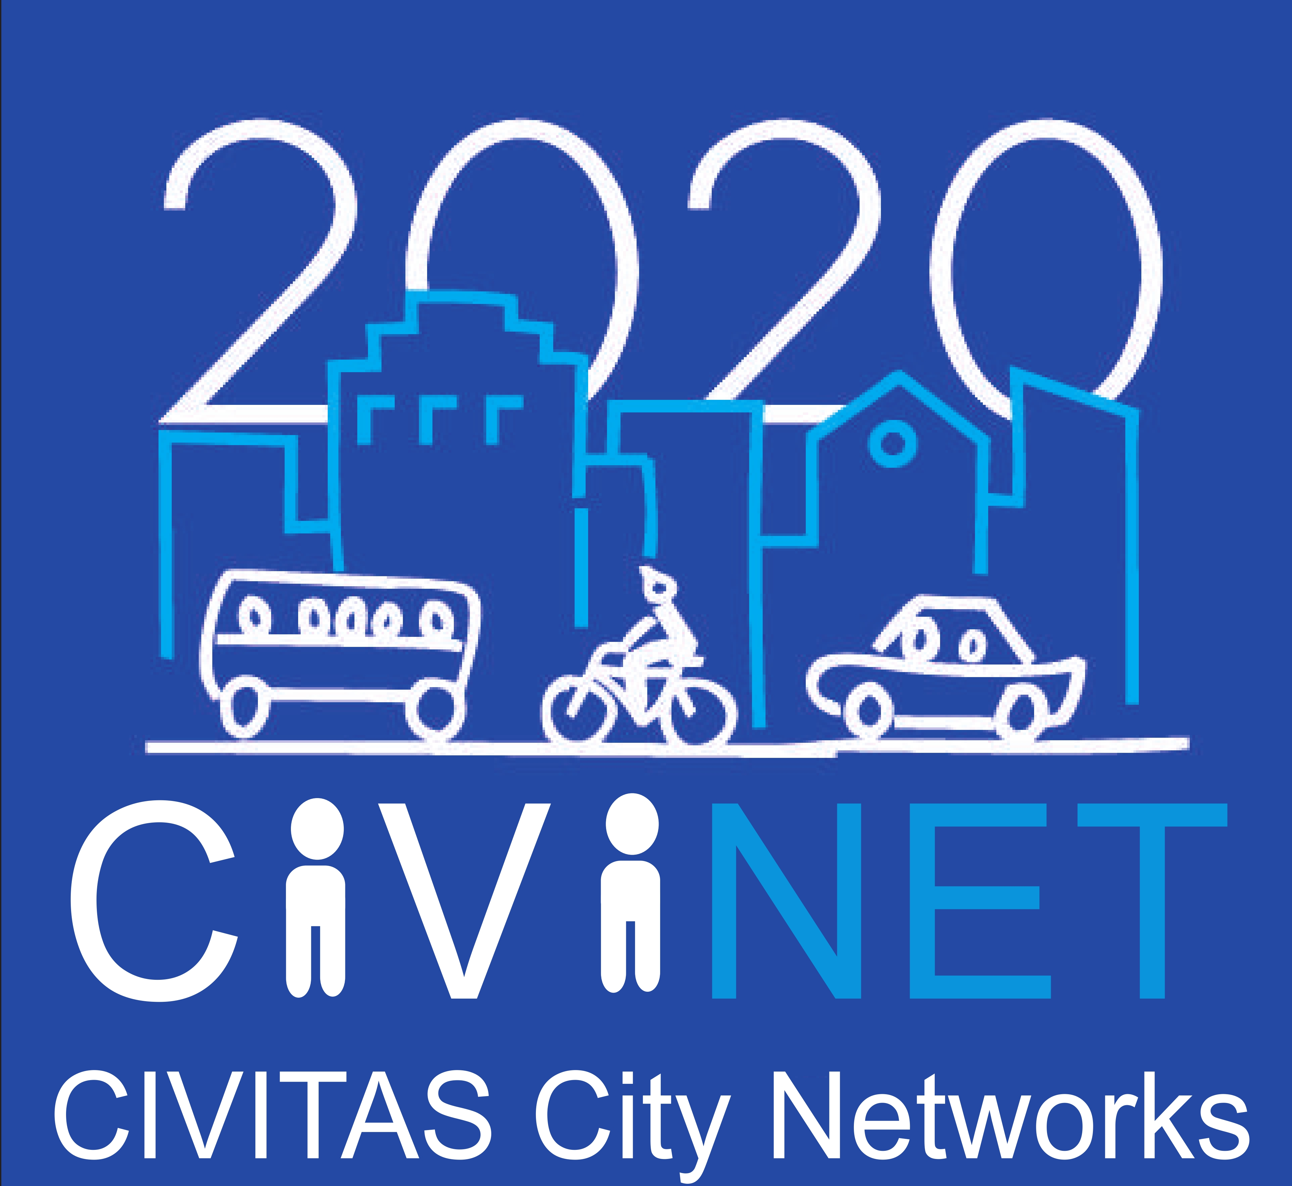

Application for organisations wishing to establish a new CIVINET network in
[Mention the geographical coverage]

Information about the applicant

City / region / organisation Legal name:
Legal address:
Street name & number: | Town / city:
Country: | Postal code:
Website:

Contact person:
Family name: | First name:
Title: | Position in organisation:
Telephone: | Fax:
Email:

Language of the CIVINET network foreseen

Context and opportunity for setting up a CIVINET network in the geographical area, proposed approach

Please briefly describe the background for proposing a CIVINET network in the geographical area:
- Critical mass of CIVITAS demonstration cities and/or CIVITAS Forum members in the geographical area
- Context
- What is your objective?

List of cities who expressed an interest / with whom you took contact with any additional comment on their specific expectations

Please, list the main cities with whom contact has been taken and explain their intention; please, describe also the potential for further members

Please, indicate if a city is already volunteering to be National Network Manager (NNM) (if different from applicant in Section 1 – must be a city or regional authority). The NNM leads the group while the Secretariat ensures the day-to-day organisation of activities:

City / region:

Legal address:
Street name & number: | Town / city:
Country: | Postal code:
Website:

Contact person:
Family name: | First name:
Title: | Position in organisation:
Telephone: | Fax:
Email:

Evidence of existing dialogue with other stakeholders

Please, describe the dialogue engaged with other stakeholders and name them. Please describe the support they could provide to the network. Include demonstration of political support and (if applicable) if they have signed the CIVITAS Declaration

Plan for a Launch event
Please explain what are your plans for setting up the network:
- Preliminary contacts and meetings: when, with whom, with what objective as outcome? Will you require the presence of our support team?
- Preparation activities: are you already thinking of a legal structure process or will you seek collaborations with committed stakeholders, what kind of document/ information will you send to the interested participants?
- Launch event – explain how it should fit in the annual calendar of events in the country(ies) covered, what would be the format and the agenda, what would be the outcome. Will you require the presence of our support team?

Envisaged structure of membership
Please, tell if you have already some idea of the network membership (only cities or other stakeholders, with which status, who would decide of the activities…? To be agreed in General Assembly of members)

Possible Activities Plan for One year
July-December 2015 will be a period of “setting up” as set out in the current application. This period should be finalised with a General Assembly of Members who adopt a 2016 plan of Activities that may receive some EC support through further Calls of the CAPITAL Activity fund. Please, indicate what your proposed network could carry out:
- Stakeholder engagement – commentary on proposed dialogue between city authorities, government departments and the European Commission.
- Sustainable Mobility events programme – an outline of proposed events, overview of content, target number of participants etc.
- Third party events – identifying & attending suitable national events not organised by your Network to raise awareness of your Network
- Dissemination activities – newsletters, media relations and advertising

Breakdown of foreseen costs
The CAPTAL Activity Fund will cover up to 75% of costs at a maximum of 6.000€ (i.e 75% of 8.000€). The grant will be paid following the presentation of the activity report, not following invoices or timesheets. The CIVINET Support team may control the accuracy of the report though.
Please, give a breakdown of foreseen costs:
- Staff costs, ideally estimated per task foreseen.
- Communication purchases – quantify leaflets, posters, etc (please note that the CIVINET Support team will provide you with a corporate logo and all templates).
- Events organisation – try to seek for supporting hosts, but mention what would be the logistics costs of the event(s) planned for launching the network
- Third party events attendance and Travel costs (please mention the number of persons)

Declaration

It is an important condition when accepting the Grant funding and entering in to an agreement to participate in CAPITAL - CIVINETs that your proposed action is ready to start immediately. You will be encouraged and assisted by the CIVINET support team to move towards Network launch as quickly as possible. The following declaration is a commitment by you to provide adequate resources, both human and financial, to achieve this obligation.
Lead applicant signature

Please return your application to civinet@civitas.eu.
For further information or enquiries please contact Marie Launay (marie.launay@europrojectconsult.eu) & Agathe Martin (agathe.martin@europrojectconsult.eu) at +33.2.40.35.00.72 or David Blackledge (david.blackledge@ttr-ltd.com) at +44.1.273.251.644.

ANNEX 1 Letters of support

Attach Letters of support in Annex 1

