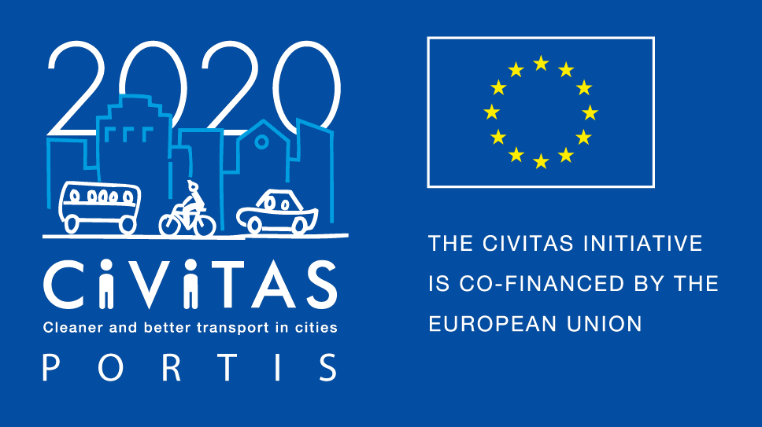
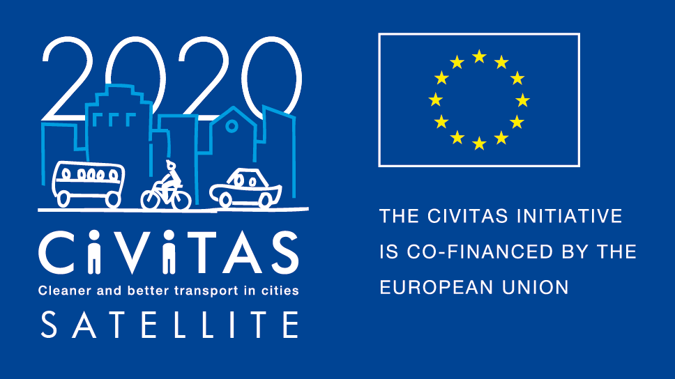
w
CIVITAS PORTIS and CIVITAS Initiative training and peer-to-peer activities -
CIVITAS Initiative & CIVITAS PORTIS Study Visit to Antwerp
Registration Form and Application for Travel Support

Project Acronym: | CIVITAS PORTIS
Full Title:
PORT-Cities: Integrating Sustainability
Grant Agreement No.: | 690713
Deadline for registration and application for travel support: | 17 April 2019
Contact email address: | International@vectos.co.uk
Contact person: | Tim Durant

The Antwerp Study Visit is jointly organised by the CIVITAS PORTIS and CIVITAS Initiative projects.
The CIVITAS PORTIS project is currently testing integrated packages of urban mobility and logistics solutions in the five European cities of Aberdeen, Antwerp, Constanta, Klaipeda and Trieste. Recognising the specific challenges of port cities and conflicts that can arise on the transport network, innovative measures being developed include: data and traffic management systems; freight guidance and coordination apps; commuter travel planning and online mobility services; as well as steps to enhance city and port environments for active travel and tourism. Although the project involves port cities, many of the sustainable mobility and logistics initiatives are nevertheless relevant to all cities.
During 2019 and 2020 PORTIS will arrange a series of face-to-face training & exchange sessions and webinars covering the topics: Governance; Innovation Processes; Behavioural Change Initiatives; Data Platforms & Apps; and Freight Coordination and Logistics. The Antwerp Study Visit incorporates the first module of these Training Sessions.
CIVITAS PORTIS is able to offer travel support funding to a limited number of city authorities, public transport authorities and port authorities. The deadline to apply to receive financial support is 17 April 2019. Please find the application form below.
CIVITAS SATELLITE is an initiative designed to support cities in gaining better access to innovative solutions and to address transport challenges by applying exchange mechanisms for transfer and take-up. Between 2017 and 2020, SATELLITE will organise at least 20 visits, in the form of work placements and study visits, for city representatives willing to learn from each other and to exchange extensively with each other. Participants for these peer-to-peer visits will be selected each year through calls for expression of interest.
For the Antwerp Study Visit the closing date for applications for funding support by CIVITAS SATELLITE has now passed and three cities have been selected to attend the event in May.
Study Visit in Antwerp - The mobility objective of the city of Antwerp is to tackle the port-city challenge, improve transport infrastructure, reduce motorized road movements, promote sustainable transport modes, and keep the Antwerp region accessible and liveable. Antwerp is partner of the project CIVITAS PORTIS. The study visit will try to cover the following topics: behavioural change, cycling and walking, mobility management and innovation process. During the visit different partners and stakeholders will be involved: City of Antwerp (coordinator Portis), Portis partners (Port of Antwerp, Public transport operators, Regional government), other CIVITAS PORTIS cities (Constanta, Trieste, Aberdeen, Klaipeda) and partners (Vectos, FGM Amor, TML).

Why join the Antwerp Study Visit - If you are a visiting city, you will:
- Have hands-on experience in another city,
- Have the opportunity to exchange on a one-to-one basis with leading peers,
- Be promoted on the CIVITAS website and European-wide media outlets as a city committed to sustainable urban mobility,
- Be offered speaker slots at European level events,
- Be able to apply for the CIVITAS award in the Take-up category

REGISTER for the event and apply for travel funding support!
Do you want take part in the Antwerp Study Visit? Please fill in the application form by 17 April 2019 and send it to international@vectos.co.uk
If you require travel funding support and are selected as a visiting city you will receive up to €700 to cover for travel and accommodation for the study visit. It will be necessary to provide us with copies of the invoices and tickets in order to reclaim travel costs.
If you have any questions then please contact Tim Durant at international@vectos.co.uk

- Representatives attending the Study Visit
Name and contact details of the person/s that will attend: | Name:  Position:  Organisation:  Telephone:  Email:  Address: | Name:  Position:  Organisation:  Telephone:  Email:  Address:
Can you confirm and make sure that your colleagues have a sufficient level of English to participate in discussions? | ☐ Yes  ☐ No
How did you find out about the Antwerp Study Visit
Do you have any special dietary requirements?
Do you have any special accessibility requirements?
Do you have any questions for us?
Would you like to apply for travel funding support? | ☐ Yes  ☐ No  If yes, please complete the additional sections and declaration below

- Information about your city
Name of the city & country
Structure & size | ☐ City  ☐ Metropolitan area  Population:
Are you member of the CIVITAS Community? | ☐ CIVITAS demonstration city  ☐ CIVITAS Forum network city  ☐ CIVINET member city  ☐ IA or RIA project partner city  ☐ None
Has your city been awarded an award for its work on sustainable mobility?  If yes, which one? | ☐ CIVITAS award  ☐ EUROPEAN MOBILITY WEEK award  ☐ SUMPs award  ☐ Other (please specify)  ☐ My city has applied or has been short listed but not selected  ☐ None
Do you have recent experience of peer-to-peer exchange?  If yes please specify | ☐ Yes (Please specify below)  ☐ No

- Preparing the visit
What are the main reason(s) why you want to take part to that CIVITAS visit?
Which key local/regional decision makers, project managers and/or stakeholders would you like to meet during your visit? Why?
Will you communicate about this visit? If yes how?

Final declaration
I have the pleasure to inform you that the city of name of the city/region supports the participation of its staff in the CIVITAS SATELLITE initiative in [2019].
Place
Click here to enter a date.
Name
Position
City/region
NB: this form should be signed by the Mayor, the Vice-Mayor or the Director of the Transport department in your municipality.

